
Guide Specification for
Lightning Protection Systems
SECTION [13 46 00] [26 41 00]

LIGHTNING PROTECTION SYSTEMS

Lightning protection systems (LPS) protect property, prevent injuries, and save lives. Their importance grows as buildings become more dependent on electronic devices that are vulnerable to lightning surges, and as climate change affects lightning activity.
East Coast Lightning Equipment (ECLE) is a leading international manufacturer of lightning protection components and produces all of its products in the USA under strict quality guidelines. We offer AIA-registered continuing education courses and invite you to call us to discuss your lightning protection needs.
Risk Assessment: Use NFPA 780, to determine if LPS is required. See calculator at https://ecle.biz/lightning-risk-assessment-guide.
Delegated Design: Because LPS must comply with strict safety standards, design is usually delegated to an LPS designer certified by the Lightning Protection Institute. Drawings and specifications prepared by project’s architect or engineer should not size components nor repeat requirements found in standards; include only optional requirements and information essential for administration and coordination of project and to communicate design intent.
Specification Coordination: This document is available in word processing format at our website. Turn on hidden text to view or print specifier notes. Edit to include only requirements pertinent to project. For reroofing projects, contact us for a guide specification tailored to limited-scope projects. A short-form specification is also available.
Drawing Coordination: Show conditions such as strike termination devices used instead of air terminals, rooftop equipment, and coordination with other building systems. Show scope of work, if necessary, to indicate auxiliary buildings or other structures requiring lightning protection.
Additional Information:
• East Coast Lightning Equipment, Inc.; +1 860-379-9072, www.ecle.biz.
• Lightning Protection Institute, +1 800-488-6864, www.lightning.org.
• Lightning Protection Institute–Inspection Program, +1 224-433-6680, lpi-ip.com.
- GENERAL
      - SUMMARY
        - Section Includes: Lightning protection system.
        - Products Furnished but Not Installed Under This Section:
Installation of surge protective devices should conform to requirements of authorities having jurisdiction for electrical work. Note that electrical codes and standards alone are not adequate for LPS or grounding an LPS.
          - Conduit for Through-Structure Penetrations: Division 03 – Concrete.
          - Surge Protective Devices: Installation specified in Division 26 – Electrical.
        - Related Requirement:
Related concrete work can include:
- Openings for through-structure penetration devices.
- Concrete-encased ground electrodes require rebar to be interconnected, have at least two inches of concrete cover, and be connected to LPS.
            - Section [_________]: [Concrete.]
Certain metal structural members and metal fabrications can be used as strike termination devices and lightning conductors. The metal items must be electrically continuous with the lightning protection system, and have minimum thickness as shown in table at end of this document.
            - Section [_________]: [Structural metal framing.]
            - Section [_________]: [Penetrations in metal deck.]
            - Section [_________]: [Metal fabrications.]
            - Section [_________]: [Roofing.]
Include prefabricated items used as strike termination devices. Verify that they meet minimum metal thickness requirements as shown in table at end of this document.
            - Section [________] [Manufactured exterior specialties.] [Spires.] [Steeples.] [Weathervanes.] [___________.]
            - Section [________]: [_______________________.]
      - REFERENCE STANDARDS
        - Lightning Protection Institute: LPI 175 – Standard of Practice for the Design, Installation and Inspection of Lightning Protection Systems.
        - National Fire Protection Association: NFPA 780 – Standard for the Installation of Lightning Protection Systems.
Projects in Canada: Retain following.
        - [National Standards of Canada: CSA B72 – Installation Code for Lightning Protection Systems.]
        - UL:
          - UL 96 – Lightning Protection Components.
          - UL 96A – Installation Requirements for Lightning Protection Systems.
          - UL 1449 – Surge Protective Devices.
      - SUBMITTALS
        - Comply with Division 01 submittal requirements.
        - Delegated Design Submittals: Submit installation drawings and product data describing lightning protection system and coordination with related work. Submittals shall state that design complies with Quality Assurance standards and be signed by system designer.
        - Qualifications Statements: Submit for:
          - System Designer.
          - Manufacturer.
          - Installer.
        - Closeout Submittals: Provide Field Quality Control documentation.
      - ADMINISTRATIVE REQUIREMENTS
Retain following for large or complex projects.
        - [Preinstallation Meeting:
          - Comply with Division 01 project meeting requirements.
          - Require attendance by system designer, installer, [________,] and firms installing work affected by Section.
          - Invite [Architect.] [Engineer.]
          - Discuss coordination of work [and] [________].]
      - SCHEDULING
An LPS installer may be one of the last trades on a jobsite, since the LPS system cannot be completed until items such as the following are complete:
- Servicing of rooftop mechanical units.
- Installation of additional rooftop equipment and building appurtenances.
- Installation of additional services or through-envelope penetrations that require surge protection.
- Modifications to building grounds.
- Installation of equipment or other metal bodies that require bonding.
        - Provide time for completion of lightning protection work after other building and rooftop work is complete.
      - QUALITY ASSURANCE
LPI certifications set rigorous standards for system designers. A Master Installer/Designer must pass five examinations (eleven and a half hours of testing) and a Master Installer must pass four exams (nine hours of testing).
        - System Designer: Individual certified as Master Installer/Designer or Master Installer by Lightning Protection Institute.
Retain CSA B72 for projects in Canada.
        - Standards: Comply with [CSA B72,] LPI 175, NFPA 780, UL 96, and UL 96A.
        - Use products and methods compatible with roofing and other building materials.
      - DELIVERY, STORAGE, AND HANDLING
        - Store components in secure, dry location.
- PRODUCTS
      - COMPONENTS
Lightning protection components are significantly different than components listed for use in electrical power systems.
        - Acceptable Manufacturer: East Coast Lightning Equipment, Inc. (ECLE).
          - Internet: www.ecle.biz.
          - Email: info@ecle.biz
          - Phone: +1 860-379-9072
          - UL-Listing: [OVTZ.E93753 (US).] [OVTZ7.E93753 (Canada).]
        - Substitutions: Firm with following qualifications will be considered in accordance with Division [00] [01] requirements:
          - UL Category OVTZ listing for lightning protection components.
          - Five years of experience on work of this size and type.
          - Employee with current Lightning Protection Institute certification as Master Installer/Designer or Master Installer.
Components are available in aluminum and copper or copper alloy. Which to use depends on galvanic reactions, compatibility with other building materials, and preferred appearance. Bi-metallic connectors are used to separate incompatible components.
Aluminum should be used in contact with aluminum, steel, and galvanized steel. Zinc roofing and sheet metal require special grade of aluminum; contact ECLE for more information. Aluminum should not be embedded in concrete or in contact with earth. Aluminum components may have greater diameter than copper components, yet may be more economical depending on cost of raw materials.
Copper and copper alloy may provide greatest strength and value over the life of a project. Use copper in contact with copper and copper alloy substrates. Note that runoff water contacting copper can stain concrete surface. Copper may develop a patina over time.
Materials are readily recyclable.
        - [Material: Aluminum, copper, or copper alloy as required by Quality Assurance standards.]
Retain above to allow system designer to installer to use most appropriate material.
Retain below to specify preferred materials to be used.
        - [Material: [Aluminum] [Copper or copper alloy] except as otherwise required by Quality Assurance standards.]
Metallic plating can be used on copper and copper alloy for appearance or to increase corrosion resistance, particularly in coastal or corrosive environments.
            - [Exposed to View on Building Exterior: [Tin-plated.] [Nickel-plated.]]
            - [Other Exterior Components: Tin-plated.]
        - [Plain Air Terminals:
          - Tip: Blunt.
The standards require air terminals to rise at least ten inches above the area it protects. While a ten-inch long rod would be acceptable in many locations, we recommend rods be at least twelve inches long. The longer rods enhance performance and the added cost is negligible.
Extra tall air terminals can also be specified for visual effect or special conditions; air terminals more than 24-inches long require bracing.
          - Length:
            - [Twelve-inches] [Fifteen-inches] [________] minimum [or as shown on Drawings,] and as required by Quality Assurance standards.
ECLE Series DT is UL listed as an air terminal. ECLE Series DF is not listed as an air terminal but meets the requirements for a strike termination device and can be used instead of an air terminal.
        - [Decorative Air Terminals:
          - [ECLE Series DT Air Terminal: 16-inch tall tapered point with [2-1/4-inch diameter] [2-3/8-inch square] molded base. Install at locations visible from [street] [________].]
          - [ECLE Series DF Decorative Finial: Install where shown on Drawings.
            - [Round cross section, [[27] [48] [72] [96] inches tall.] [Height shown on Drawings.]
            - [Square cross section, 30 inches tall.]]]
      - ACCESSORIES
        - Fasteners and Adhesives: Types suitable for conditions of use.
Ground inspection wells are optional. They simplify testing of lightning protection during life of building.
        - [Ground Inspection Wells: [Schedule 80 PVC] [Steel] [Concrete], 12-inches diameter minimum, with cast iron lid. [Provide traffic-bearing types at surfaces intended for vehicular traffic.]]
        - [Conduit: [Schedule 40 PVC conduit. [Use exterior grade on building exterior].] [________.]]
        - Surge Protective Devices: Comply with NFPA 780, UL96A, and UL 1449.
        - [Decorative Glass Balls: 4-1/2-inch diameter; [clear] [cobalt] [emerald] [milk white] [ruby].]
        - [_______________________________.]
- EXECUTION
      - INSTALLER
The key to reliable lightning protection is a LPI-certified installer that has a reputation for dependable work. ECLE can introduce you to installers whose work we respect. Note that few electrical contractors have training or certification for lightning protection work.
        - Acceptable Installer:
          - [__________________.]
          - [__________________.]
          - [__________________.]
          - [Substitutions will be considered in accordance with Division [00] [01] requirements.]
        - Qualifications: Firm shall have:
          - UL-listing under UL Category OWAY for lightning protection installation.
          - Dealer/Contractor certification by Lightning Protection Institute.
          - Employee certified as Master Installer/Designer or Master Installer by Lightning Protection Institute.
      - EXAMINATION
        - Verify that conditions are acceptable for work of this Section. Do not proceed until detrimental conditions are remediated.
      - PREPARATION
        - Protect finished surfaces against damage by work of this Section.
      - INSTALLATION
Retain following, if necessary, to clarify scope of work requiring lightning protection. Coordinate with Drawings to avoid duplicating or conflicting requirements.
        - [Scope of Work:
          - Install lightning protection system to:
            - [Building and building appurtenances.]
            - [Freestanding structures including [signs,] [smokestacks,] [solar collectors,] [antennas,] [fences,] [motorized gates,] [above-grade tanks,] [trees,] [__________,] [and] [as shown on Drawings].]
            - [____________________.]]
Retain following, if necessary. If project has multiple structures, indicate which will contain hazardous materials.
          - [Comply with requirements for [flammable vapor, flammable gases, or liquids that give off flammable vapors] [explosive materials].]
Retain following if building has “architectural” qualities. Coordinate with Materials paragraph if color of materials is critical.
        - Air Terminals:
Air terminals can be set back up to 24 inches from perimeter of building to reduce visibility from ground.
          - [Set back from edge of roof] [and] [install on backside of parapets] except where otherwise required by Quality Assurance standards.]
          - [Facades with Modular Spacing: Air terminal visible from the ground shall be spaced to coincide with module.]
          - [________.]
        - Conductors:
Concealed systems provide a more durable and attractive installation. NFPA 780 permits conductors under roofing and roof framing, behind exterior wall facing, between wall studding, in conduit chases, and embedded in concrete or masonry.
          - [Provide concealed system [except that conductors on low slope roofs may be exposed].]
If a concealed system is not practical, it may be necessary to retain the following paragraph. NFPA says “Down conductors located in runways, driveways, school playgrounds, cattle yards, public walks, or other locations subject to physical damage or displacement shall be guarded… for a minimum distance of 6 ft. above grade.” Depending upon nature of project and conditions, you may want to specify more stringent requirements. In addition to abuse, consider the potential of theft of the metal.
          - [Exposed Down Conductors:
            - [Install on surfaces that are least visible from street and away from building entrances. Align with other building elements to minimize visual impact.]
            - [Protection:
              - [Method: Install in [conduit.] [________.]]
              - [Locations: [Provide at all locations.] [Provide at [locations indicated on Drawings] [_______] and as required by Quality Assurance standards.]]
              - [Height: [____] feet above grade.]]
      - FIELD QUALITY CONTROL
        - Inspection Certificate:
          - Lightning Protection Institute – Inspection Program, Master Installation Certificate.
The following is recommended because some lightning protecting firms will obtain inspection certificates for work they did not actually install. Check credentials in advance -- do not wait until your project has been damaged by lightning.
          - Name of "Installation Contractor" on LPI-IP certificate shall be same as name of Installer approved to perform work of this Section.
        - Project Record Drawings: Show locations and types of concealed work and deviations from design submittals.
      - PROTECTION
        - Protect lightning protection system against damage.
END OF SECTION

©2021 by East Coast Lightning Protection Equipment, Inc. Qualified design and construction professionals may copy for preparation of construction specifications or purchase orders. Issued 2021-July-05, contact us for current information.

REFERENCE INFORMATION: Remove prior to issuing document. For additional information see www.ecle.biz or contact us at 888-680-9462 or info@ecle.biz.

MasterFormat Section Number: The 2020 edition of MasterFormat moved lightning protection from Division 26 – Electrical to Division 13 – Special Construction. You can continue to use Division 26, if preferred, to align with widespread industry practice of including lightning protection in electrical contractor’s bid.

Drawing showing general arrangement of lightning protection system
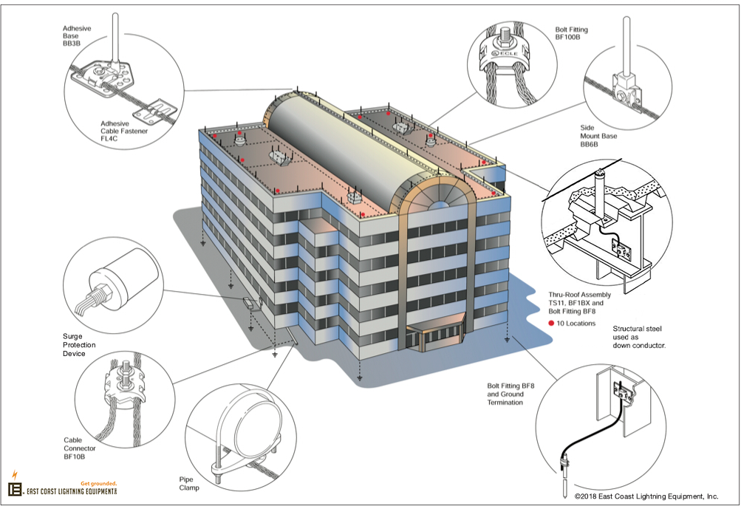

Minimum Thickness of Metal Fabrications and Structural Members Used as Part of LPS
Metal Fabrication | Strike Termination Devices | Main Conductors
Handrails and Ladders | Can be used instead of air terminal if minimum thickness meets either of following criteria: | Can be used as main conductor if minimum thickness meets either of following criteria:
NFPA 780 | 3/16” (0.1875”) or 4.8 mm  §4.6.1.4 | 0.064” or 1.63 mm  §4.9.3.2; applies to “handrails and guardrails”
UL96A | 1/8” (0.125”) or 3 mm  §8.8.1; applies to “permanent exterior metal handrails and ladders” | 0.1026” or 2.6 mm  §9.1.2
Structure & Other Fabrications  NFPA 780 | 3/16” (0.1875”) or 4.8 mm  §4.6.1.4, applies to “parts of a structure” | 3/16” (0.1875”) or 4.8 mm  §4.19.1; applies to “structural systems”

